**Task 11**

**Computer Network Lab**



**Submitted to Sir Rasikh Ali  
Submitted by Muhammad Ibtisam**

**Roll #: SU92-BSSEM-F22-288  
Section: SE-5B**

**Submitted on Dec 10th, 2024**

**DEPARTMENT OF SOFTWARE ENGINEERING  
SUPERIOR UNIVERSITY, LAHORE**

**Question:**

**DHCP:**

* DHCP is a network protocol that automatically assigns IP addresses and other network configuration parameters to devices on a network. This eliminates the need for manual configuration, making network management more efficient.

**Example:**

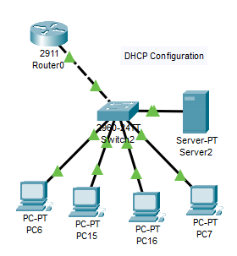

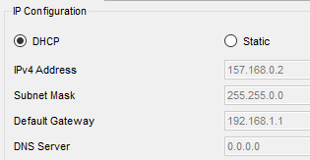

**VLAN:**

* A VLAN is a logical grouping of devices on a network. It allows you to segment a physical network into multiple virtual networks, improving security, performance, and manageability. Each VLAN forms its own broadcast domain, isolating traffic between different VLANs

**Example:**

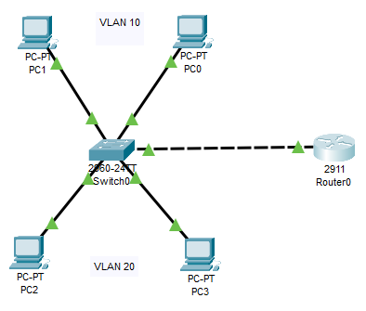

**DNS:**

* DNS is a hierarchical naming system for computers, services, or any resource connected to the Internet or a private network. It translates human-readable domain names (like google.com) into machine-readable IP addresses. This allows users to access websites and other network resources by name, rather than by IP address.

**Example:**

